COS 226 Algorithms and Data Structures Fall 2010

Final
This test has 14 questions worth a total of 100 points. You have 180 minutes. The exam is closed book, except that you are allowed to use a one page cheatsheet (8.5-by-11, both sides, in your own handwriting). No calculators or other electronic devices are permitted. Give your answers and show your work in the space provided. Write out and sign the Honor Code pledge before turning in the test.
“I pledge my honor that I have not violated the Honor Code during this examination.”
Problem | Score | Problem | Score
0 |  | 7
1 |  | 8
2 |  | 9
3 |  | 10
4 |  | 11
5 |  | 12
6 |  | 13
Sub 1 |  | Sub 2
Total

Name:
Login ID:
Precept:
P01 11 Bob Tarjan P02 12:30 Yuri Pritykin P02A 12:30 Bob Tarjan P03 1:30 Aman Dhesi P03A 1:30 Siyu Yang
1
0. Miscellaneous. (1 point)
Write your name and Princeton NetID in the space provided on the front of the exam, and circle your precept number.
1. Analysis of algorithms. (12 points)
Which of the following can be performed in linear time in the worst case? For the purposes of this question, assume P Write P (possible), I (impossible), or U (unknown).
= NP .
−−− Find a maximum spanning tree in a connected edge-weighted graph. −−− Find all vertices reachable from a given set of source vertices in a digraph. −−− Find a Hamilton path in a digraph (if one exists).
A Hamilton path is a simple path that visits each vertex in the digraph exactly once. −−− Find a Hamilton path in a DAG (if one exists). −−− Find the strong components of a digraph. −−− Insert N Comparable keys into a binary heap. −−− Sort an array of N Comparable keys. −−− Insert N Comparable keys into a binary search tree. −−− Compute the inverse Burrows-Wheeler transform. −−− Insert N strings into an R-way trie.
(Here, linear means linear in the sum of the lengths of the N strings.) −−− Print the N strings in a ternary search trie in ascending order. (Here, linear means linear in the sum of the lengths of the N strings.) −−− Perform a nearest-neighbor query in a 2-d tree.
2. Equivalence relations. (5 points)
Which of the following are equivalence relations? Put a . next to those that are equivalence relations.
−−− v.equals(w) for objects in a Java class that correctly implements the equals() method
−−− v.compareTo(w) < 0 for objects in a Java class that correctly implements the Comparable interface
−−− connected(v, w) in CC for connectivity in an undirected graph
−−− reachable(v, w) in TransitiveClosure for reachability in a digraph
−−− stronglyConnected(v, w) in KosarajuSCC for strong connectivity in a digraph
Recall, an equivalence relation ≡ is a binary relation that is
- reﬂexive: v ≡ v
- symmetric: if v ≡ w, then w ≡ v
- transitive: if v ≡ w and w ≡ x, then v ≡ x

3. Depth-ﬁrst search. (8 points)
(a) Run depth-ﬁrst search on the digraph below, starting at vertex A. Assume the adjacency lists are in sorted order: for example, when exploring vertex F , consider the edge F → C before F → E or F → H.
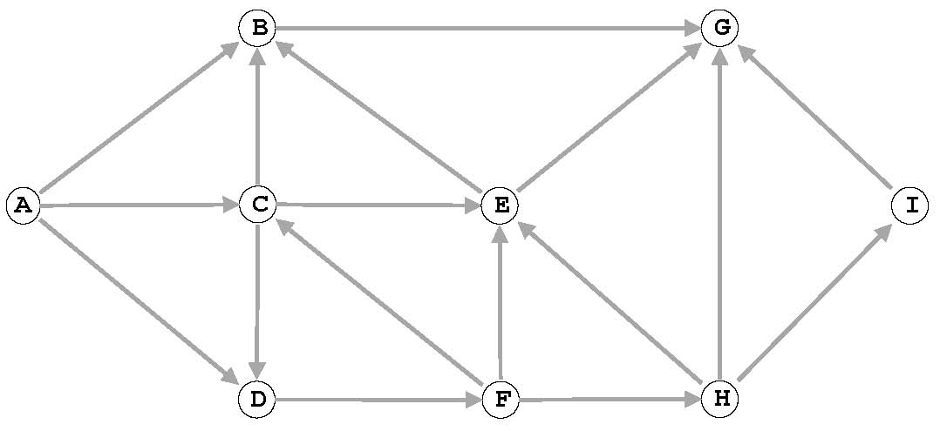
List the vertices in preorder and postorder.
preorder: A B ___ ___ ___ ___ ___ ___ ___
postorder: G B ___ ___ ___ ___ ___ ___ ___
(b) Consider two vertices x and y that are simultaneously on the function-call stack at some point during the execution of depth-ﬁrst search from vertex s in a digraph. Which of the following must be true?
I. There is both a directed path from s to x and a directed path from s to y.
II. If there is no directed path from x to y, then there is a directed path from y to x.
III. There is both a directed path from x to y and a directed path from y to x.
(a) I only. | (d) I, II and III.
(b) I and II only. | (e) None.
(c) I and III only.

4. Minimum spanning tree. (8 points)
Consider the following edge-weighted graph with 9 vertices and 19 edges. Note that the edge weights are distinct integers between 1 and 19.

(a) Complete the sequence of edges in the MST in the order that Kruskal’s algorithm includes them (by specifying their edge weights).
(b) Complete the sequence of edges in the MST in the order that Prim’s algorithm includes them (by specifying their edge weights). Start Prim’s algorithm from vertex A.

1 ____ ____ ____ ____ ____ ____ ____
The edge-weighted graph from the previous page is repeated here for reference.
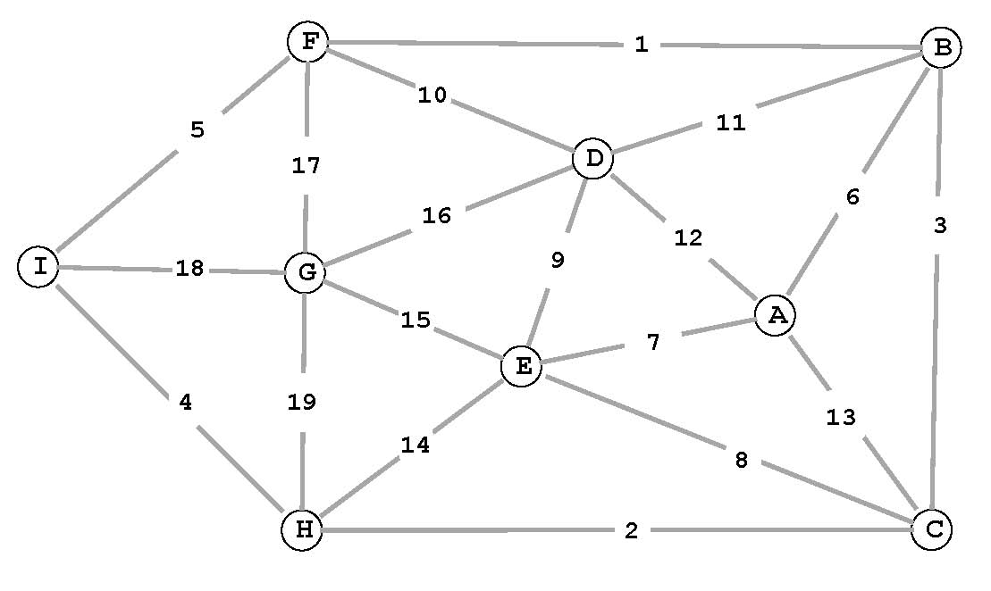
6 ____ ____ ____ ____ ____ ____ ____
5. Shortest paths. (10 points)
Run the eager version of Dijkstra’s algorithm on the following edge-weighted digraph, starting from vertex 0.
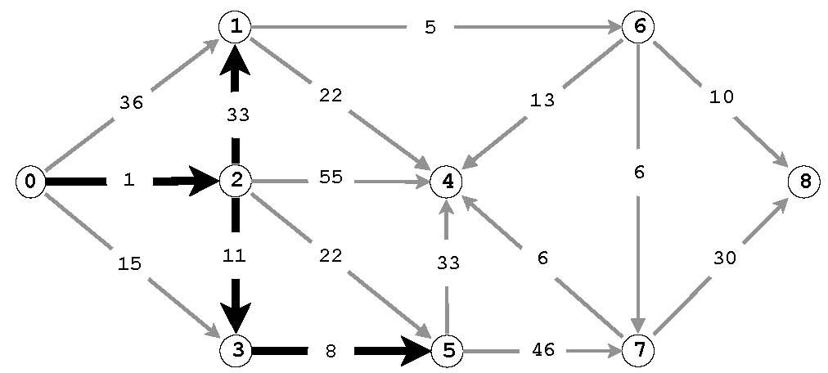
(a) Complete the table of edgeTo[] and distTo[] values immediately after the ﬁrst 5 vertices (0, 2, 3, 5, and 1) have been deleted from the priority queue and relaxed.
(b) Complete the table of edgeTo[] and distTo[] values immediately after the 6th vertex has been deleted from the priority queue and relaxed. Circle those values that changed from (a).
(c) Draw the edges in the (ﬁnal) shortest-paths tree with thick lines in the ﬁgure above.

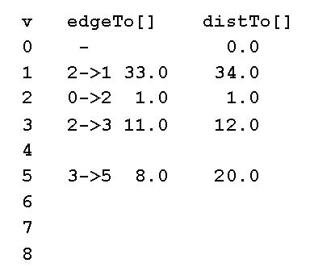
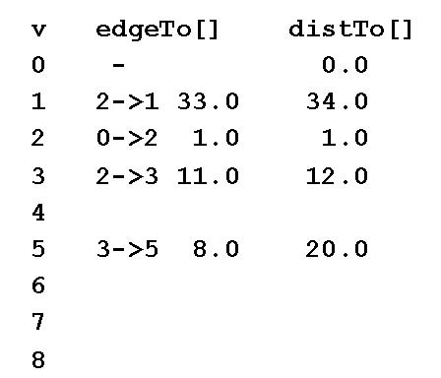
6. Polar sort. (6 points)
Consider the following proposed Comparator for sorting points in the plane by polar angle with respect to a base point. It is based on the ccw method from lecture.
import java.util.Comparator;
public class Point { private final int x, y;
public final Comparator<Point> POLAR_ORDER = new PolarOrder();
public Point(int x, int y) { this.x = x; this.y = y; }
// is a->b->c a counterclockwise turn? // -1 if clockwise; +1 if counterclockwise; 0 if collinear public static int ccw(Point a, Point b, Point c) {
double area2 = (b.x-a.x)*(c.y-a.y) -(b.y-a.y)*(c.x-a.x); if (area2 < 0) return -1; else if (area2 > 0) return +1; else return 0;
}
// compare q1 and q2 by polar angle they make with this point private class PolarOrder implements Comparator<Point> { public int compare(Point q1, Point q2) { return ccw(Point.this, q2, q1); } } }
(a) What is the fatal ﬂaw with the Comparator implementation? Note: there is nothing wrong with the Java code (and Point.this is Java’s obscure way of referring to the enclosing object from within a nested class). Do not worry about integer overﬂow.
(b) Suggest an easy approach to ﬁxing the ﬂaw.

7. Kd-trees. (8 points) The ﬁgures below illustrate the results of inserting points 1 through 10 into a 2d-tree.
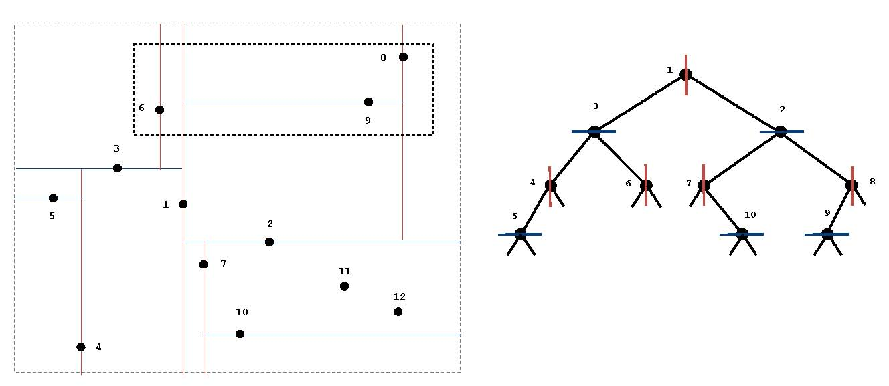
(a) Circle all of the the points below in the 2d-tree that are examined (not necessarily just those inside the query rectangle) during the range search for the query rectangle speciﬁed above.
1 2 3 4 5 6 7 8 9 10
(b) Draw the result of inserting point 11, then point 12 in the two ﬁgures above.

8. Substring search. (6 points) Create the Knuth-Morris-Pratt DFA for the string abcabac over the alphabet { a, b, c }
by completing the following table. As usual, state 0 is the start state and state 7 is the accept state.
0 |  |  | 1 |  | 2 |  | 3 |  | 4 |  | 5 |  | 6
a | 1 | 1 |  |  |  | 4 |  |  |  | 6
b | 0 | 2 |  |  |  |  |  | 5
c | 0 | 0 |  | 3 |  |  |  |  |  |  |  | 7

You may use the following partially-completed graphical representation of the DFA for scratch work (but we will consider your solution to be the completed table above).
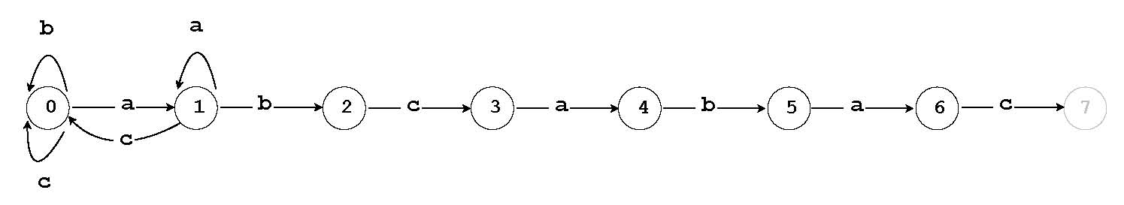
9. Regular expressions. (6 points) Convert the regular expression (a(bc|d)*) into an equivalent NFA (nondetermin
istic ﬁnite state automaton) using the algorithm described in lecture and the textbook by adding E-transition edges to the diagram below.
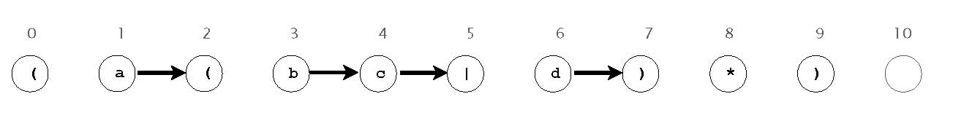
10. Substring search and pattern matching. (7 points) For each algorithm on the left (the version discussed in lecture and the textbook),
give the best-matching worst-case order of growth on the right.
−−−−−− brute-force substring search for a query string of size M A. M in a text string of size N
B. N/M −−−−−− Knuth-Morris Pratt substring search for a query string of
C. Nsize M in a text string of size N D. M + N
−−−−−− Boyer-Moore (with only mismatch heuristic) substring search for a query string of size M in a text string of size
E. MN
N
F. 2M −−−−−− Monte Carlo version of Rabin-Karp substring search (that
checks only for a hash match) for a query string of size M G. 2N in a text string of size N
−−−−−− regular-expression pattern matching for a pattern of size M on a text string of size N
−−−−−− simulating a DFA with M vertices and 2M edges on a text string of size N
−−−−−− simulating an NFA with M vertices and 3M edges on a text string of size N
11. Huﬀman codes. (5 points) Consider the following variable-length codes for the 36-character text string:
FCFCECACBDEDFEABFBAFFCDCBEDFFFCCDEEF
symbol freq code 1 code 2 code 3 code 4 code 5
A | 3 | 110 | 011 | 011 | 1110 | 100
B | 4 | 111 | 010 | 010 | 1111 | 101
C | 8 | 10 | 00 | 00 | 00 | 01
D | 5 | 010 | 110 | 101 | 110 | 110
E | 6 | 011 | 001 | 100 | 10 | 111
F | 10 | 00 | 10 | 11 | 01 | 00

Identify each code (on the left) with the best-matching descriptions (on the right). Write as many letters next to each code as apply.
−−−−−− code 1 A. preﬁx-free code
−−−−−− code 2 B. Huﬀman code (assume that when merging the two minimal subtries, either subtrie can become the left or right child)
−−−−−− code 3
C. optimal preﬁx-free code
−−−−−− code 4
−−−−−− code 5
12. Cyclic rotation of a strings. (9 points) A string s is a cyclic rotation of a string t if s and t have the same length and s consists of a
suﬃx of t followed by a preﬁx of t. Design a linear-time algorithm to determine whether one string is a cyclic rotation of another. You may assume they have the same length N.
For example, "winterbreak" is a cyclic rotation of "breakwinter" (and vice versa).
Your answer will be graded on correctness, eﬃciency, clarity, and succinctness. Let N denote the length of s and t. For full credit, the running time of your algorithm should be proportional to N in the worst case.
(a) Describe your algorithm in the space below.
(b) What is the order of growth of the worst-case running time of your algorithm as a function of N? Circle the best answer.

1 log NNN log NN2 N3
13. Reductions. (9 points) Consider the following two problems:
- Multiplication. Given two N-bit integers x and y, compute x × y.
- Squaring. Given an N-bit integer x, compute x.

2
We measure the running time as a function of the number of bits in the input(s). For example, adding or subtracting two N-bit integers takes time proportional to N using the standard grade-school algorithm.
Potentially useful facts about integers: (a + b)2 = a2 + b2 +2ab;(a − b)2 = a2 + b2 − 2ab, (a + b)(a − b)= a2 − b2 .
(a) Show that Squaring linear-time reduces to Multiplication. To demonstrate your reduction, give the Multiplication instance(s) that you would construct to solve the
2
following Squaring instance: given x, compute x.
(b) Show that Multiplication linear-time reduces to Squaring. To demonstrate your reduction, give the Squaring instance(s) that you would construct to solve the following Multiplication instance: given x and y, compute x × y.
(c) Suppose that Alice discovers an N log log log N algorithm for Squaring and Bob discovers an Nα(N) lower bound for Multiplication, where α(N) is a really really slowly growing (but super-constant) function. Which of the following can you infer from the fact that Squaring and Multiplication linear-time reduce to one another?

I. There does not exist a linear-time algorithm for Multiplication.
II. Squaring and Multiplication have the same asymptotic complexity.
III. There exists an N log log log N algorithm for Multiplication.
(a) I only. (d) I, II and III.
(b) I and II only. (e) None.
(c) I and III only.

16

